Reflection-Asymmetric Shapes
# Source: AI Source: Provided by: [Data Path: Persons Table -> ID Column: 1, Name_En Column: Motasem Essam] -> From: [ChatGPT] on [7/25/2026]
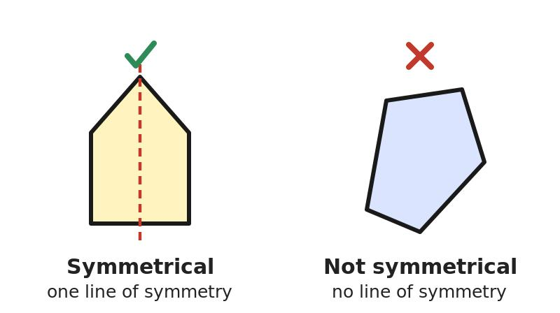
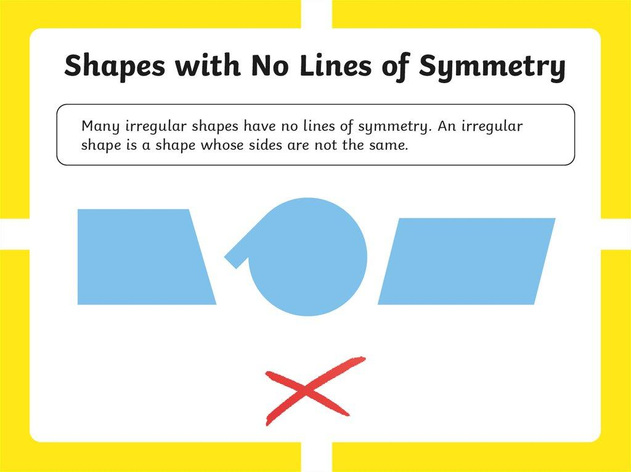
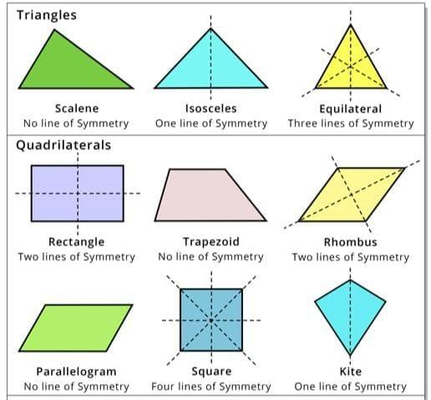
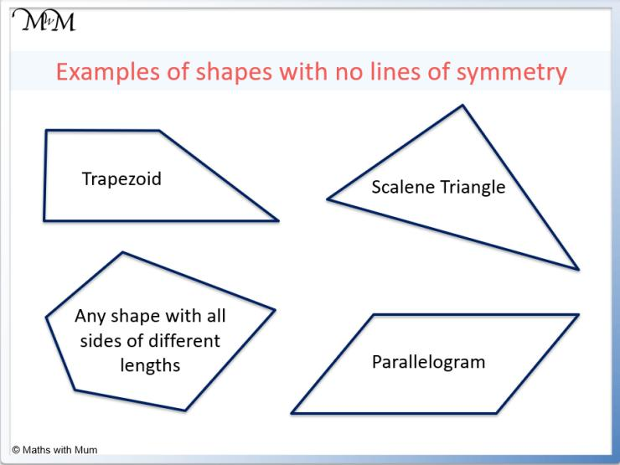

Definition
# Source: AI Source: Provided by: [Data Path: Persons Table -> ID Column: 1, Name_En Column: Motasem Essam] -> From: [ChatGPT] on [7/25/2026]
Reflection-Asymmetric Shapes are shapes that do not remain unchanged when reflected across a specified line.
In other words, the shape has no reflection symmetry with respect to the line being considered.
If S represents a shape and R represents a reflection transformation, the shape is reflection-asymmetric with respect to that reflection when:
$$\boxed{R\left(S\right)≠S}$$
A reflection-asymmetric shape may still possess other types of symmetry, such as rotational symmetry.

Fundamental Concept
# Source: AI Source: Provided by: [Data Path: Persons Table -> ID Column: 1, Name_En Column: Motasem Essam] -> From: [ChatGPT] on [7/25/2026]
Reflection symmetry means that one half of a shape is the mirror image of the other half across a line called the line of symmetry.
For a reflection-asymmetric shape, no such reflection line exists among the lines being considered.
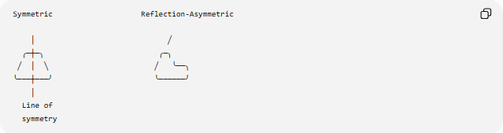
Symmetric Reflection-Asymmetric

│ ╱
╭─┼─╮ ╭─╮
╱ │ ╲ ╱ ╰──╮
╰───┼───╯ ╰──────╯
│
Line of
symmetry
The key property is therefore:
$$\boxed{\text{No Reflection Symmetry}}$$

Main Characteristics
# Source: AI Source: Provided by: [Data Path: Persons Table -> ID Column: 1, Name_En Column: Motasem Essam] -> From: [ChatGPT] on [7/25/2026]
Reflection-asymmetric shapes generally have:
- no line of reflection symmetry
- unequal corresponding sides or curves
- unequal distribution of features about any reflection line
- potentially irregular proportions
- potentially curved or straight boundaries
- potentially regular or irregular local components
- possible rotational symmetry
- possible point symmetry
Importantly:
$$\boxed{\text{Reflection-Asymmetric}≠\text{Completely Asymmetric}}$$
A shape can lack reflection symmetry while still having rotational symmetry.

Types of Reflection-Asymmetric Shapes
# Source: AI Source: Provided by: [Data Path: Persons Table -> ID Column: 1, Name_En Column: Motasem Essam] -> From: [ChatGPT] on [7/25/2026]
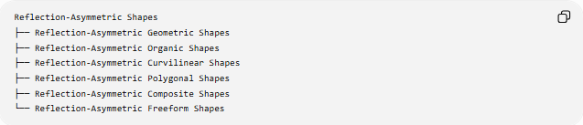
Reflection-Asymmetric Shapes
├── Reflection-Asymmetric Geometric Shapes
├── Reflection-Asymmetric Organic Shapes
├── Reflection-Asymmetric Curvilinear Shapes
├── Reflection-Asymmetric Polygonal Shapes
├── Reflection-Asymmetric Composite Shapes
└── Reflection-Asymmetric Freeform Shapes
These are descriptive subcategories based on the structure of the shape.

Reflection-Asymmetric Geometric Shapes
# Source: AI Source: Provided by: [Data Path: Persons Table -> ID Column: 1, Name_En Column: Motasem Essam] -> From: [ChatGPT] on [7/25/2026]
A Reflection-Asymmetric Geometric Shape is a mathematically defined geometric shape that has no line of reflection symmetry.
Examples can include:
- scalene triangles
- many irregular polygons
- general asymmetric quadrilaterals
- certain composite geometric shapes
Example: Scalene Triangle
A scalene triangle has three unequal sides:
$$a≠b≠c$$
and generally has no line of reflection symmetry.
Thus:
$$\boxed{\text{Scalene Triangle}→\text{Reflection-Asymmetric}}$$

Reflection-Asymmetric Organic Shapes
# Source: AI Source: Provided by: [Data Path: Persons Table -> ID Column: 1, Name_En Column: Motasem Essam] -> From: [ChatGPT] on [7/25/2026]
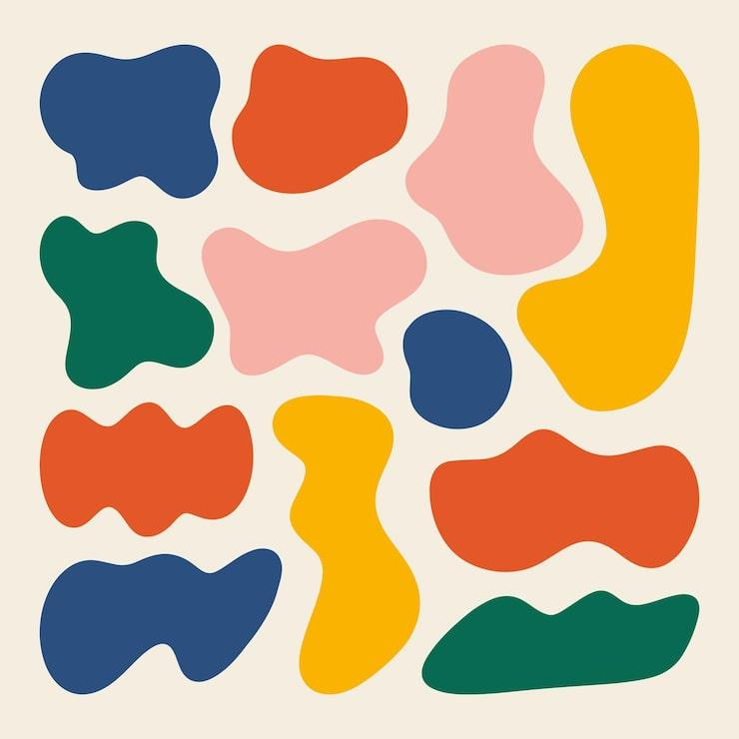
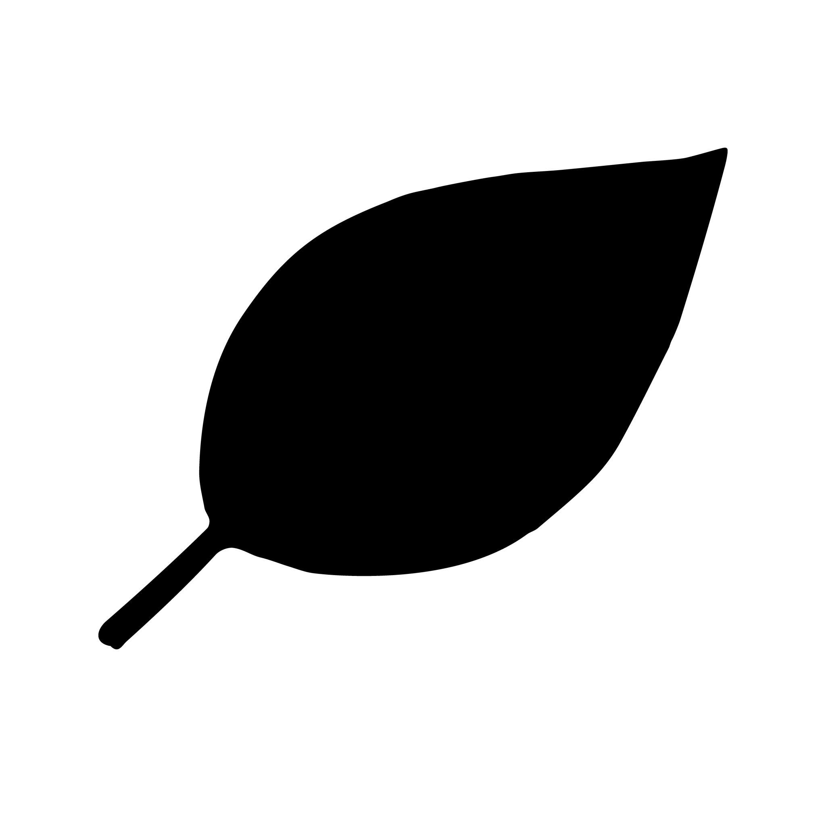

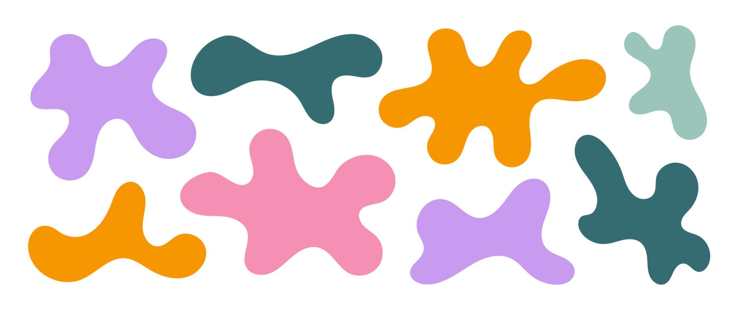
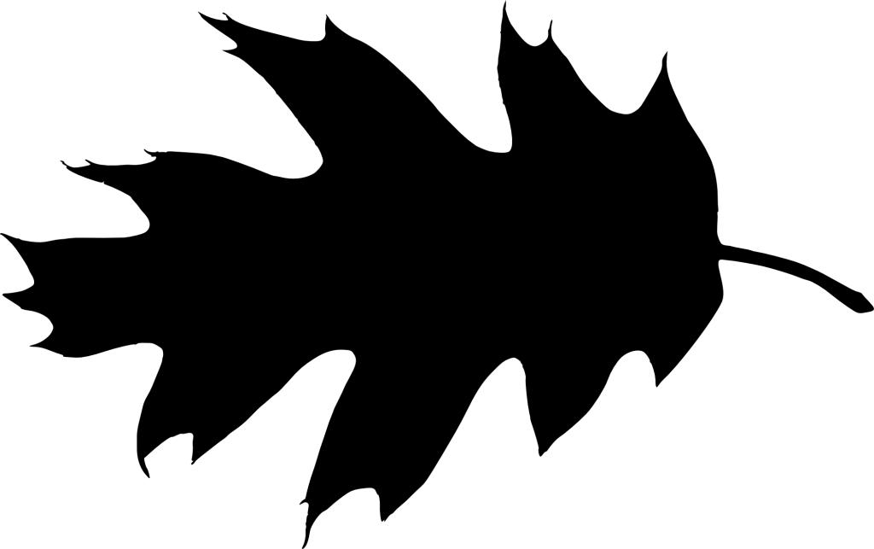

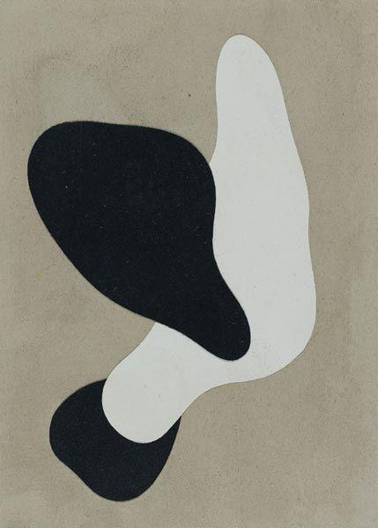
Reflection-Asymmetric Organic Shapes have natural or flowing forms without a reflection axis.
Examples include shapes resembling:
- irregular leaves
- stones
- clouds
- natural fragments
- biological forms
Their asymmetry may result from unequal:
- widths
- curves
- protrusions
- indentations
- proportions

Reflection-Asymmetric Curvilinear Shapes
# Source: AI Source: Provided by: [Data Path: Persons Table -> ID Column: 1, Name_En Column: Motasem Essam] -> From: [ChatGPT] on [7/25/2026]
A Reflection-Asymmetric Curvilinear Shape has curved boundaries without a reflection axis.
For example:
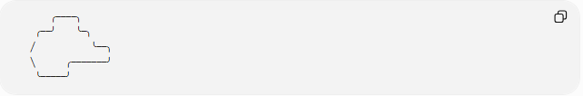
╭────╮
╭──╯ ╰─╮
╱ ╰──╮
╲ ╭───────╯
╰─────╯
The left and right sides do not correspond as mirror images.
Such a shape can be:
- smooth
- wavy
- freeform
- organic
- composite

Reflection-Asymmetric Polygonal Shapes
# Source: AI Source: Provided by: [Data Path: Persons Table -> ID Column: 1, Name_En Column: Motasem Essam] -> From: [ChatGPT] on [7/25/2026]
A Reflection-Asymmetric Polygonal Shape is a polygon with no line of reflection symmetry.
Examples include:
- scalene triangles
- irregular quadrilaterals
- many irregular pentagons
- many irregular hexagons
A polygon may have equal sides or equal angles in some places and still lack reflection symmetry.
Therefore:
$$\boxed{\text{Irregularity and reflection-asymmetry are different properties}}$$

Reflection-Asymmetric Composite Shapes
# Source: AI Source: Provided by: [Data Path: Persons Table -> ID Column: 1, Name_En Column: Motasem Essam] -> From: [ChatGPT] on [7/25/2026]
A Reflection-Asymmetric Composite Shape consists of multiple components arranged without reflection symmetry.
For example:
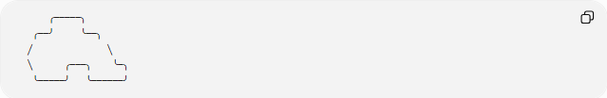
╭─────╮
╭──╯ ╰──╮
╱ ╲
╲ ╭───╮ ╰─╮
╰─────╯ ╰──────╯
The individual components may themselves be symmetric, but their overall arrangement can be reflection-asymmetric.
This is an important distinction:
$$\boxed{\text{Symmetric Components}⇏\text{Symmetric Composite}}$$

Reflection-Asymmetric Freeform Shapes
# Source: AI Source: Provided by: [Data Path: Persons Table -> ID Column: 1, Name_En Column: Motasem Essam] -> From: [ChatGPT] on [7/25/2026]
Reflection-Asymmetric Freeform Shapes are custom shapes with curved or flexible boundaries that have no reflection axis.
They may be:
- smooth
- organic
- abstract
- decorative
- irregular
Their lack of symmetry can be intentional.
For example, a custom freeform curve can be defined by:
$$y=f\left(x\right)$$
where there is no line x=c such that reflection across that line reproduces the same shape.

Mathematical Test for Reflection Symmetry
# Source: AI Source: Provided by: [Data Path: Persons Table -> ID Column: 1, Name_En Column: Motasem Essam] -> From: [ChatGPT] on [7/25/2026]
For a graph:
$$y=f\left(x\right)$$
reflection symmetry about the y-axis exists when:
$$\boxed{f\left(-x\right)=f\left(x\right)}$$
If:
$$\boxed{f\left(-x\right)≠f\left(x\right)}$$
then the graph is asymmetric with respect to the y-axis.
Example
Consider:
$$f\left(x\right)=x^{2}+x$$
Then:
$$f\left(-x\right)=x^{2}-x$$
Since:
$$x^{2}-x≠x^{2}+x$$
the graph is not symmetric about the y-axis.

Reflection About a Vertical Line
# Source: AI Source: Provided by: [Data Path: Persons Table -> ID Column: 1, Name_En Column: Motasem Essam] -> From: [ChatGPT] on [7/25/2026]
For reflection about a vertical line:
$$x=h$$
a function has reflection symmetry when:
$$\boxed{f\left(h+d\right)=f\left(h-d\right)}$$
for corresponding values of d.
If this equality does not hold, the shape does not have reflection symmetry about x=h.

Reflection About a Horizontal Line
# Source: AI Source: Provided by: [Data Path: Persons Table -> ID Column: 1, Name_En Column: Motasem Essam] -> From: [ChatGPT] on [7/25/2026]
For shapes represented appropriately as a relation between x and y, reflection about:
$$y=k$$
requires corresponding points to map onto each other:
$$\left(x , k+d\right)⟶\left(x , k-d\right)$$
If the reflected shape differs from the original:
$$\boxed{R_{y=k}\left(S\right)≠S}$$
then the shape is reflection-asymmetric about that line.

Reflection Transformation
# Source: AI Source: Provided by: [Data Path: Persons Table -> ID Column: 1, Name_En Column: Motasem Essam] -> From: [ChatGPT] on [7/25/2026]
A reflection across a vertical line:
$$x=h$$
maps a point:
$$\left(x , y\right)$$
to:
$$\boxed{\left(2 , h-xy\right)}$$
For reflection across a horizontal line:
$$y=k$$
the transformation is:
$$\boxed{\left(x , 2k-y\right)}$$
A shape is reflection-symmetric only if the transformed set of points is identical to the original set.
For a reflection-asymmetric shape:
$$\boxed{R\left(S\right)≠S}$$

Reflection-Asymmetry vs Irregularity
# Source: AI Source: Provided by: [Data Path: Persons Table -> ID Column: 1, Name_En Column: Motasem Essam] -> From: [ChatGPT] on [7/25/2026]
These concepts should not be confused.
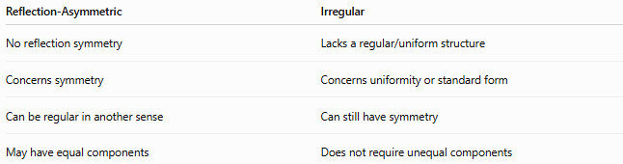
Reflection-Asymmetric | Irregular
No reflection symmetry | Lacks a regular/uniform structure
Concerns symmetry | Concerns uniformity or standard form
Can be regular in another sense | Can still have symmetry
May have equal components | Does not require unequal components
For example, a shape can be irregular but reflection-symmetric.
Conversely, a mathematically regular arrangement can potentially lack reflection symmetry depending on the structure being considered.

Reflection-Asymmetric vs Rotationally Asymmetric
# Source: AI Source: Provided by: [Data Path: Persons Table -> ID Column: 1, Name_En Column: Motasem Essam] -> From: [ChatGPT] on [7/25/2026]
These are different properties.
A shape may have:
$$\text{No reflection symmetry}$$
but still have:
$$\text{Rotational symmetry}$$
For example, some centrally symmetric shapes have 180° rotational symmetry without having a reflection axis.
Therefore:
$$\boxed{\text{Reflection-Asymmetric}⇏\text{Rotationally Asymmetric}}$$

Reflection-Asymmetric vs Completely Asymmetric
# Source: AI Source: Provided by: [Data Path: Persons Table -> ID Column: 1, Name_En Column: Motasem Essam] -> From: [ChatGPT] on [7/25/2026]
Reflection-asymmetric specifically concerns reflection symmetry.
Completely asymmetric would mean the shape has no non-trivial symmetry of the relevant types.
Thus:
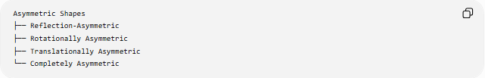
Asymmetric Shapes
├── Reflection-Asymmetric
├── Rotationally Asymmetric
├── Translationally Asymmetric
└── Completely Asymmetric
A reflection-asymmetric shape may still have rotational or point symmetry.

Examples

Example 1 — Scalene Triangle
# Source: AI Source: Provided by: [Data Path: Persons Table -> ID Column: 1, Name_En Column: Motasem Essam] -> From: [ChatGPT] on [7/25/2026]
A scalene triangle has no line of reflection symmetry.
$$\boxed{\text{Reflection-Asymmetric}}$$

Example 2 — Irregular Curved Shape
# Source: AI Source: Provided by: [Data Path: Persons Table -> ID Column: 1, Name_En Column: Motasem Essam] -> From: [ChatGPT] on [7/25/2026]
An irregular curved boundary with unequal left and right portions generally has no reflection axis.
$$\boxed{\text{Reflection-Asymmetric}}$$

Example 3 — Asymmetric Freeform Shape
# Source: AI Source: Provided by: [Data Path: Persons Table -> ID Column: 1, Name_En Column: Motasem Essam] -> From: [ChatGPT] on [7/25/2026]
A custom freeform shape with different curves on opposite sides can lack reflection symmetry.
$$\boxed{\text{Reflection-Asymmetric}}$$

Example 4 — Symmetric Shape
# Source: AI Source: Provided by: [Data Path: Persons Table -> ID Column: 1, Name_En Column: Motasem Essam] -> From: [ChatGPT] on [7/25/2026]
A circle has infinitely many reflection axes.
$$\boxed{\text{Not Reflection-Asymmetric}}$$

Classification by Boundary
# Source: AI Source: Provided by: [Data Path: Persons Table -> ID Column: 1, Name_En Column: Motasem Essam] -> From: [ChatGPT] on [7/25/2026]
Reflection-asymmetric shapes can also be classified according to their boundaries:
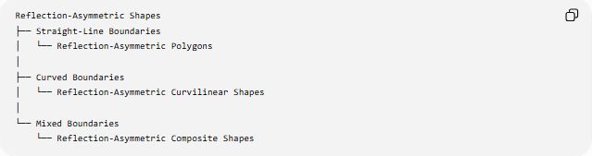
Reflection-Asymmetric Shapes
├── Straight-Line Boundaries
│ └── Reflection-Asymmetric Polygons
│
├── Curved Boundaries
│ └── Reflection-Asymmetric Curvilinear Shapes
│
└── Mixed Boundaries
└── Reflection-Asymmetric Composite Shapes
This classification describes what the shape is made of, while reflection-asymmetry describes how the shape behaves under reflection.

Classification Summary
# Source: AI Source: Provided by: [Data Path: Persons Table -> ID Column: 1, Name_En Column: Motasem Essam] -> From: [ChatGPT] on [7/25/2026]
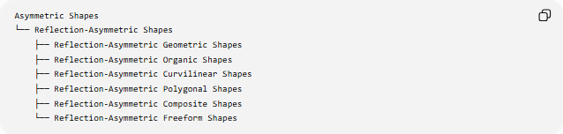
Asymmetric Shapes
└── Reflection-Asymmetric Shapes
├── Reflection-Asymmetric Geometric Shapes
├── Reflection-Asymmetric Organic Shapes
├── Reflection-Asymmetric Curvilinear Shapes
├── Reflection-Asymmetric Polygonal Shapes
├── Reflection-Asymmetric Composite Shapes
└── Reflection-Asymmetric Freeform Shapes
A more mathematical structure is:
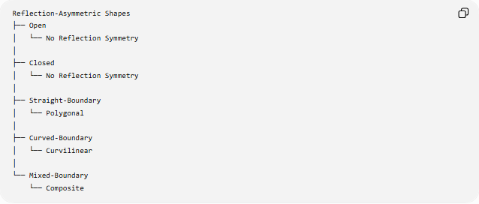
Reflection-Asymmetric Shapes
├── Open
│ └── No Reflection Symmetry
│
├── Closed
│ └── No Reflection Symmetry
│
├── Straight-Boundary
│ └── Polygonal
│
├── Curved-Boundary
│ └── Curvilinear
│
└── Mixed-Boundary
└── Composite

Key Points
# Source: AI Source: Provided by: [Data Path: Persons Table -> ID Column: 1, Name_En Column: Motasem Essam] -> From: [ChatGPT] on [7/25/2026]
- Reflection-Asymmetric Shapes have no reflection symmetry with respect to the specified reflection line or lines being considered.
- Reflection maps the shape to a different shape:
$$\boxed{R\left(S\right)≠S}$$
- They may be geometric, polygonal, curvilinear, organic, composite, or freeform.
- A scalene triangle is a common geometric example.
- Reflection-asymmetry does not necessarily mean the shape has no other symmetry.
- A shape may lack reflection symmetry while retaining 180° rotational symmetry.
- Reflection-asymmetry is different from irregularity.
- Reflection-asymmetry is a property of the whole shape, even when its individual components are symmetric.
- The relevant reflection line should be specified when testing symmetry.

Conclusion
# Source: AI Source: Provided by: [Data Path: Persons Table -> ID Column: 1, Name_En Column: Motasem Essam] -> From: [ChatGPT] on [7/25/2026]
Reflection-Asymmetric Shapes are shapes that do not map onto themselves under reflection across the line or lines being considered. They can occur across many different shape families, including polygons, curvilinear shapes, organic shapes, and freeform shapes.
The central relationship is:
$$\boxed{\text{Reflection-Asymmetric }⟺ R\left(S\right)≠S}$$
for the specified reflection transformation R.
Thus, reflection-asymmetry describes a symmetry property, not a particular geometric form.

